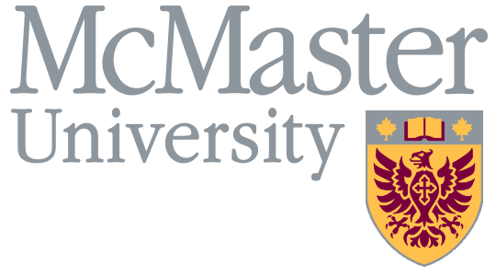
Vacation Exchange Program for TMG
Application Form
Eligible Employees, as defined in the Program Guide, may make a one-time application to exchange one week of their annual vacation entitlement for a 2% increase in base salary. This vacation exchange will reduce an Eligible Employee’s vacation entitlement on a permanent and ongoing basis until retirement.
To be completed by the Employee
Employee ID:
Employee Name:
Email and Extension:
Department:
Declared Retirement Date:
Note: This date must be the first of a month.

I am voluntarily applying for the Vacation Exchange Program for TMG. Subject to my meeting program eligibility requirements, I understand that I will receive a one-time increase of 2% in my base salary, my vacation entitlement will be reduced by one week on a permanent and ongoing basis until retirement, and I commit to retire within 3 years. I understand that, once approved, this application is irrevocable and that my Declared Retirement Date may not be later than three years in the future, as noted above.
Signature of Employee: | Date:

Supervisor Approval and Information
Immediate Supervisor | Name:
 | Title:
 | Mailing Address:
 | Email Address:
 | Date:
 | Signature:
Department Head | Name:
 | Title:
 | Mailing Address:
 | Email Address:
 | Date:
 | Signature:
Director of Administration (or equivalent) | Name:
 | Title:
 | Mailing Address:
 | Email Address:
 | Date:
 | Signature:
Key Dates for Applicants
The completed application deadline is |  |  | By April 30
Your application will be reviewed by Human Resources Services to confirm whether or not you meet the eligibility requirements of the program. |  |  | You will be informed of the outcome by June 30th
If approved, you will receive a one-time 2% increase in base salary |  |  | Effective July 1 of the year in which you applied
If approved, your annual vacation entitlement will be permanently reduced by 1 week |  |  | Effective the year following your application year and continuing until retirement

Please send the completed application form to:
Dejana Corovic, Total Rewards
corovic@mcmaster.ca

